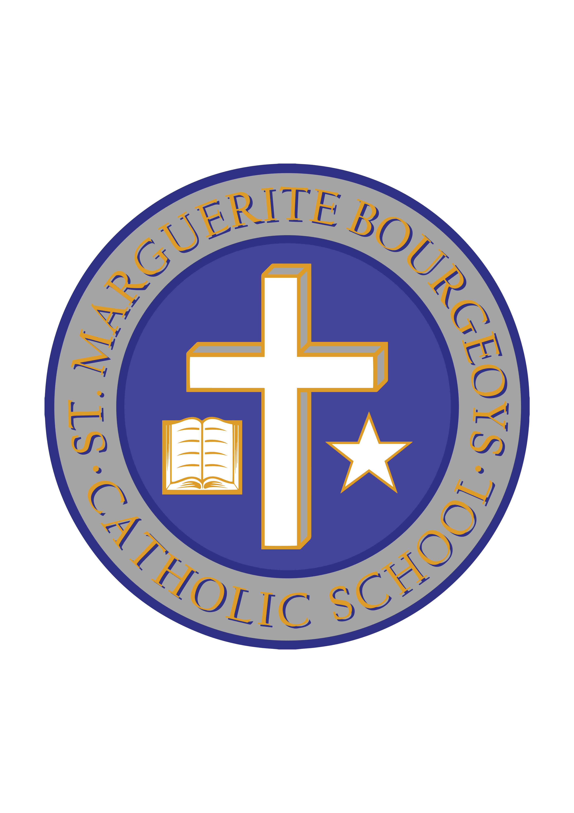

School Cash Online

Dear Parent/Guardian,

The Algonquin and Lakeshore Catholic District School Board will be using School Cash Online as the method of payment for all school fees, everything from field trips to milk.

School Cash Online allows parents to pay for school related fees safely, quickly and easily. By using School Cash Online, you help increase efficiency and security at schools.

St. Marguerite Bourgeoys Catholic School will be implementing certain events and other school fees available for your child/children for online purchases. You can keep track of which school fees require your attention by registering at https://alcdsb.schoolcashonline.com/

If parents run into problems finding their school or student when registering please visit: http://schoolcashonline.com/home/support.

Thank you.

Sincerely,

Mr. Douglas
Principal
St. Marguerite Bourgeoys Catholic School

